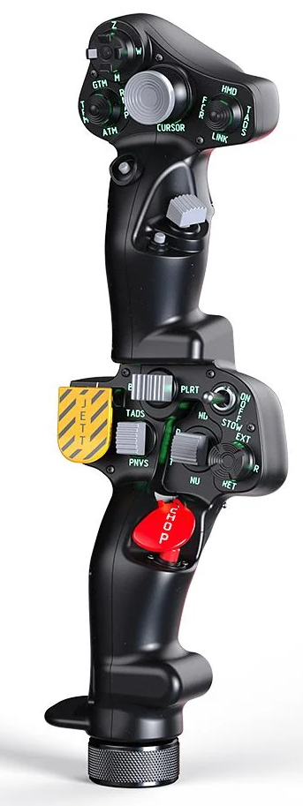  1xx - Controls | 2xx - Ground | 3xx - Flight | 4xx - A2A | 5xx - A2G | 6xx - Misc
102 - Controls - Pilot - Collective Grip Apache-64
U=Up, D=Down, F=Forward, B=Backward, L=Left, R=Right, P=Press, S-*=Shift-*, L-*=Long-*

Top Trigger
- P: Uncage Shkval, designate target (if using HMS, press and hold, look at target, then release; if not using HMS, sets Shkval on automatic left/right scan)
FCR Scan Size hat (top)
- U: Shkval narrow view (23x)
- D: Shkval wide view (7x)
- R: Shkval target frame decrease size
- L: Shkval target frame increase size
- P: Shkval center
FCR Mode hat (left)
- U: Airborne target head-on on/off
- D: Airborne target on/off
- R: Ground moving target on/off
- L: Turn on target on/off
- P: Flares
Sight Select hat (right)
- U: Autopilot pitch hold
- D: Autopilot heading hold
- L: Autopilot bank hold
- R: Autopilot altitude hold
- P: Hover hold on/off
Cursor hat (Ministick)
- Axes: Slew Shkval TV sensor
- P: Lock target
Cursor Select button (under ministick)
- P: Targeting system reset button (turns off Shkval and sets HUD to nav mode; if cannon is still selected, some cannon symbology will remain)
FCR Scan switch (thumb) -- Comms
- F: (SRS radio 1 PTT)
- B: (SRS radio 2 PTT)
- P: (VoiceAttack PTT)
- S-P: (VoiceAttack center mouse cursor)
Cued Search button (under thumb switch)
- P: Helmet-Mounted Sight on/off (or NVG if fitted instead)
Top Pinky button
- P: Parking brakes (toggle)
-------------------------------------------------------------------------------------------------------------------------------------
Bottom trigger
- P: Collective brake - Assign altitude lever
Boresight rocker
- L: TV contrast down
- P: --
- R: TV contrast up
Searchlight switch
- F: Landing light (spotlight) switch up
- B: Landing light (spotlight) switch down
- B and Hold: --
Searchlight hat
- U/D/L/R: Move spotlight
- P: --
Jettison button
- P: --
- P and Hold: External stores jettison
NVS switch
- F: TV brightness up
- P: --
- B: TV brightness down
Stabilator switch
- F: Engine dust/de-icing switch up
- P: --
- B: Engine dust/de-icing switch down
Chop button
- P: --
- P and Hold: --
Bottom Pinky button
- P: Parking brakes (toggle)

